Traffic sign Detection and recognition (TSDR)

Traffic sign recognition systems consist of two main stages:

detection :In this stage we identify the position and size of the traffic sign in the image. The detection of a traffic sign is crucial part as it affects the next stages of TSDR

Examples:

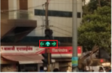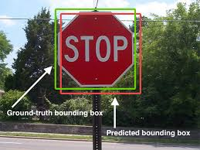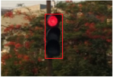

Several methodsof Detection

shape based detection

The Hough transformation usually isolates features of a particular shape within a given frame/images. It was applied by Zaklouta et al. in [59] to detect triangular and circular signs. Their own test datasets contained 14,763 and 1584 signs, and the accuracy rate was approximately 90%. The main advantage of the Hough transformation technique is that it is tolerant of gaps in feature boundary descriptions and  
is relatively unaffected by image noise

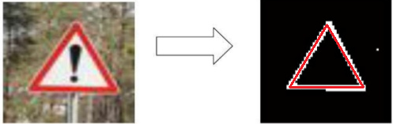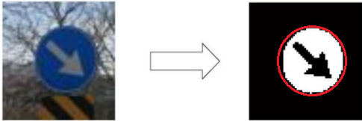

Haar feature-based Cascade Classifier initially proposed by Viola and Jones [4], [5] classifies objects using a series of edge, line, and center-surround features that scan throughout the image to construct ROI features. The name cascade means the resultant classifier consists of several simpler classifiers that are applied to the image one at a time in the order of their classification effectiveness. Subhasis Das in []Mobile Traffic Sign Recognition Subhasis Das, Milad Mohammadi {subhasis, milad}@stanford.edu Stanford University . used 500 positive images and 750 negative images at each stage of the detector. After the training period, After evaluation they hit 90% accuracy. Haar feature-based Cascade Classifier is efficient and highly accurate

learning-based detection